
Canon Burrows C of E Primary & Nursery School
Excellence in Handwriting Policy, Letter Chatter and
Programme of Lessons

Excellence in Handwriting Policy

Overall aims:

- -The school to establish and maintain a high profile of handwriting and presentation skills by displaying and rewarding children's outstanding efforts and achievements.
-The school to raise children’s self-motivation and esteem through establishment of best handwriting practice.
-Each child to write in a clear, fluent, semi-cursive, legible style of handwriting.
-Each child to write at ease with a good pace.
-The children to take pride in the presentation of all their written work.
-Children use their skills with confidence in real life situations.

Continuity and Progression:
EYFS Physical development outcomes:
30 - 50 months
- Holds a pencil between thumb and two fingers, NO longer using whole hand grasp.
- Holds pencil near point between first two fingers and thumb and uses it with GOOD control.
- Can copy some letters, e.g. letters from their name.
40 - 60 months
- Begins to use anticlockwise movement and retrace vertical lines.
- Begins to form recognisable letters.
- Uses a pencil and holds it effectively to form recognisable letters, MOST of which are correctly formed.

Learning and Teaching in EYFS:
*In EYFS Squiggle while you Wiggle is used to practice gross motor skills by creating handwriting movements with the body.
*In EYFS Dough Disco is used to enhance fine motor skills and pincer grip needed in the early development of handwriting.
*The teaching of letter formation begins with the introduction of initial letter families using the school ‘letter chatter’ to get a consistent patter (see CB letter chatter 2017) and Canon Burrows Excellence in Handwriting Policy (this document).
*A minimum of three discrete 20 minutes sessions per week.
*The teaching and learning of handwriting is reinforced during modelled, shared and guided writing and phonics sessions.

YEAR 1
National Curriculum 2014 end of year expectations:
- Sit correctly at a table.
- Holding a pencil comfortably and correctly begin to form lower-case letters in the correct direction.
- Starting and finishing in the right place.
- Form capital letters.
- Form digits 0-9.
- Understand which letters belong to which handwriting ‘families’ (i.e. letters that are formed in similar ways) and to practice these, using the Canon Burrows Excellence in Handwriting Policy for letter families (this document).

Non Statutory Guidance: Handwriting requires frequent and discrete, direct teaching. Pupils should be able to form letters correctly and confidently. The size of the writing implement (pencil, pen) should not be too large for a young pupil’s hand. Whatever is being used should allow the pupil to hold it easily and correctly so that bad habits are avoided. Left-handed pupils should receive specific teaching to meet their needs.

Learning and Teaching in Year 1:
*The teaching of letter formation continues with letter families (refer to KS1 P of L in this policy) and using the school ‘letter chatter’ to get a consistent patter (refer to CB letter chatter 2017 in this policy).
*A minimum of two discrete 20 minutes sessions per week.
*The teaching and learning of handwriting is reinforced during modelled, shared and guided writing, phonics and spelling sessions.

YEAR 2
National Curriculum 2014 end of year expectations:
- Form lower-case letters of the correct size relative to one another.
- Start using some of the diagonal and horizontal strokes needed to join letters and understand which letters, when adjacent to one another, are best left unjointed (as shown in this document).
- Write capital letters and digits of the correct size, orientation and relationship to one another and to lower-case letters.
- Use spacing between words that reflects the size of the letters.

Non Statutory Guidance: Pupils should revise and practise correct letter formation frequently. They should be taught to write with a joined style as soon as they can form letters securely with the correct orientation.

Learning and Teaching in Year 2:
*The teaching of letter formation continues with letter families (refer to KS1 P of L in this policy) and using the school ‘letter chatter’ to get a consistent patter (refer to CB letter chatter 2017 in this policy).
*Teach letter formation for correct size and orientation-in particular focus on capitals and lower case.
*A minimum of two discrete 20 minutes sessions per week.
*The teaching and learning of handwriting is reinforced during modelled, shared and guided writing, phonics and spelling sessions.

YEARS 3 and 4
- Use the diagonal and horizontal strokes that are needed to join letters and understand which letters, when adjacent to one another, are best left un-joined (as shown in this document).
- Increase the legibility, consistency and quality of their handwriting, for example, by ensuring that the down strokes of letters are parallel and that lines of writing are spaced sufficiently so that the ascenders and descenders of letters do not touch.

Non Statutory Guidance:
Pupils should be using joined handwriting throughout their independent writing. Handwriting should continue to be taught, with the aim of increasing the fluency with which pupils are able to write down what they want to say. This, in turn, will support their composition and spelling.

Learning and Teaching in Year 3 and 4:
*The teaching of letter formation and joins continues with letter families (refer to KS2 Pof L in this policy) and using the school ‘letter chatter’ to get a consistent patter (refer to CB letter chatter 2017 in this policy).
*A minimum of two discrete 20 minutes sessions per week.
*The teaching and learning of handwriting is reinforced during modelled, shared and guided writing and spelling sessions.
*Teachers’ identify children who have not achieved end of Year 2 handwriting expectations for small group interventions. Use the KS1 P of S from this document for these children.

YEARS 5 and 6 - referred to as 'handwriting AND presentation'.
- Write legibly, fluently and with increasing speed by:
-choosing which shape of a letter to use when given choices and
-deciding whether or not to join specific letters.
- Choosing the writing implement that is best suited for a task

Non Statutory Guidance:
Pupils should continue to practise handwriting and be encouraged to increase the speed of it, so that problems with forming letters do not get in the way of their writing down what they want to say. They should be clear about what standard of handwriting is appropriate for a particular task, for example, quick notes or a final handwritten version. They should also be taught to use an unjoined style, for example, for labelling a diagram or data, writing an email address, or for algebra and capital letters, for example, for filling in a form.

Learning and Teaching in Year 5 and 6:
*The teaching of letter formation and joins continues with letter families (refer to KS2 P of L in this policy) and using the school ‘letter chatter’ to get a consistent patter (refer to CB letter chatter 2017 in this policy).
*A minimum of two discrete 20 minutes sessions per week.
*The teaching and learning of handwriting is reinforced during modelled, shared and guided writing and spelling sessions.
*Teachers’ identify children who have not achieved end of Year 4 handwriting expectations for small group interventions. Use the KS 1 and 2 P of S from this document for these children.

Inclusion
The aim is that all of our pupils are able to write legibly and fluently. However, some pupils may need more support. At Canon Burrows children who are having difficulty forming letters correctly or having problems developing a cursive style are monitored. Intervention groups are set up, individual targets created and progress is tracked.

Other tools may be necessary to support individuals e.g. pencil grips, triangular pencils, sloping boards etc. Provision is matched to need and inclusive handwriting environments are established in all classes.
To ensure that left-handed children are not disadvantaged when writing a range of strategies are employed. Left-handed children sit on the left of right-handed children to ensure that their arms do not clash, and they are also encouraged to tilt their work clockwise so they can see what they have written.
Monitoring and Assessment

It is an essential the school assess handwriting at several levels:
-Whole school assessment
-Class assessment
-Individual assessment
-Self assessment and
-Peer assessment

Adopting a whole school approach
At Canon Burrows we recognise that:
-Changing handwriting takes a lot of time and effort.
Staff have regular CPD and promote the learning and teaching of handwriting in positive ways (Martin Harvey consultant training 2016-17).
-Encouragement is essential.
Handwriting learning/celebration walls in all classrooms promote self-esteem and further raise the profile of handwriting and presentation.
-Short, regular, frequent periods of practice are much more effective than longer sessions.
Staff timetable a minimum of discrete x2 handwriting sessions per week.
-Modelling is key.
Teachers model both right and left handed movements and vocalize the size, shape and movement of the pencil using the handwriting terminology in this document, ISHA Excellence in Handwriting document and the school’s letter chatter.
-Teaching at home does not set up conflicts for the child between home and school.
Staff update Year Group web pages with information about handwriting, this policy is available for parents on line and workshops are organised to support parents understanding of the learning and teaching of handwriting.
-The right tools are essential, at Canon Burrows we use:
Pencils and pens:
- Use a good quality HB handwriting pencil.
- Ensure pencils are always sharp and is not too short.
- Offer a minimum of two good quality pens should be available for personal choice
Paper:
- Write in books with the handwriting guides in, or plain books and children use line guides.

Letter Families and Formation.
For further information to support the learning and teaching of the letter families and letter formation using the agreed chatter please refer to ‘ISHA Achieving Excellence in Handwriting’ document pages 4-16.

LOWER CASE FORMATION
Family 1. The Straight Line Family – i, l, t and j
Letters based on a single vertical line.
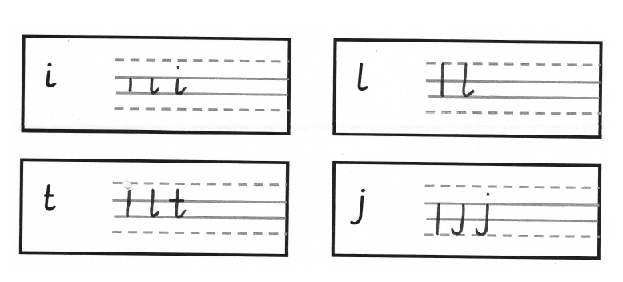

Family 2. The Coathanger Family – c, o, a, d, g and q.

Letters based on a ‘c’ shape.
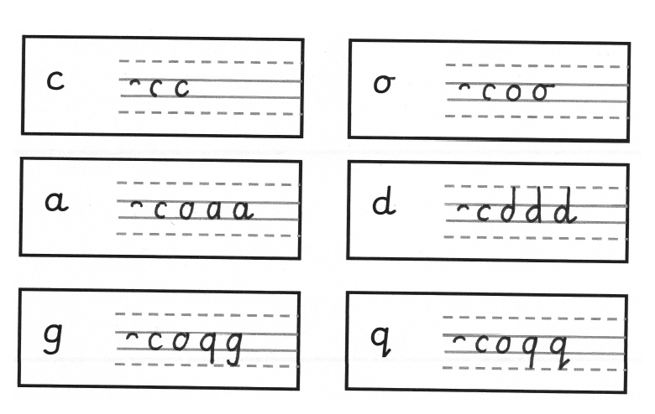

Family 2. The Coathanger Family continued – e

Letters based on a ‘c’ shape, but it does not start with the hook like other letters in this family.
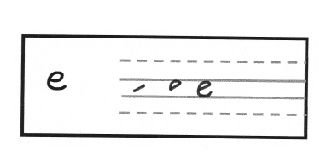

Family 3. The Bridge Family – n, m and r.

Letters based on vertical down stroke followed by a diagonal movement to the right.
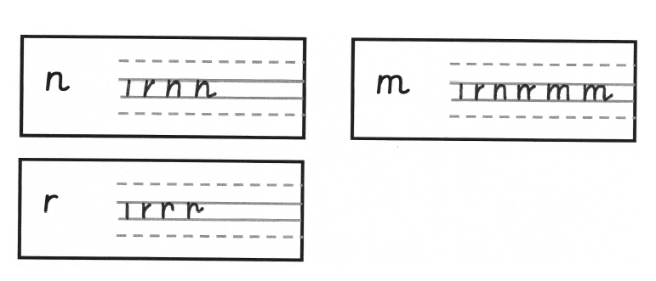

Family 3. The Bridge Family continued – h, b, k and p.

Letters based on vertical down stroke followed by a vertical up stroke, then have a diagonal movement to the right.
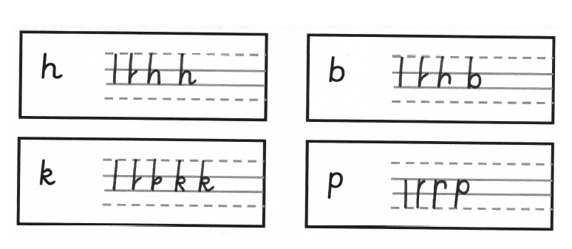

Family 4. The Zig Zag Family – v and w.

Letters based on diagonal downward stroke .

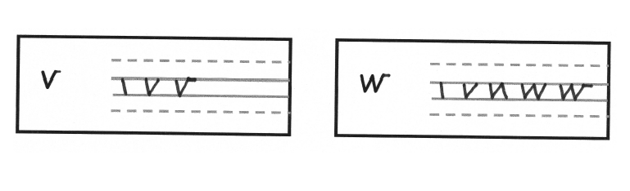
Family 5. The Smile Family – u and y.

Letters based on a downward stroke, curve back up and then down.

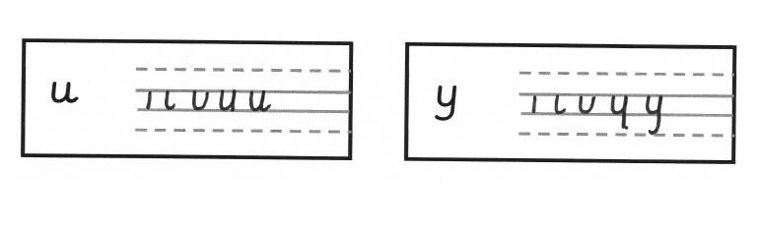
Family 6. The Misfits! S, f, x and z.
Unique and individual, they do not fit other letter groups (See ISHA Excellence in Handwriting pages 12 for more information).

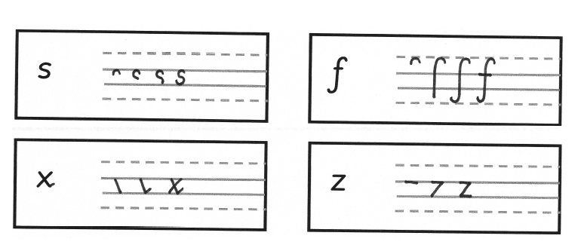

UPPER CASE FORMATION

These are taught as tall letters in size. They do NOT join on to the letter which follows.

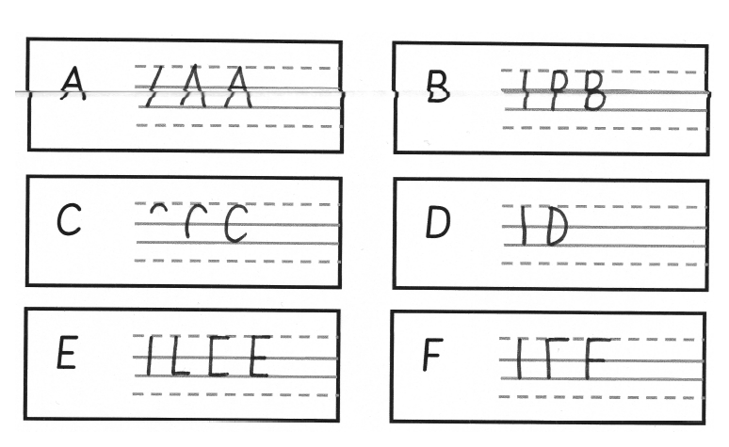

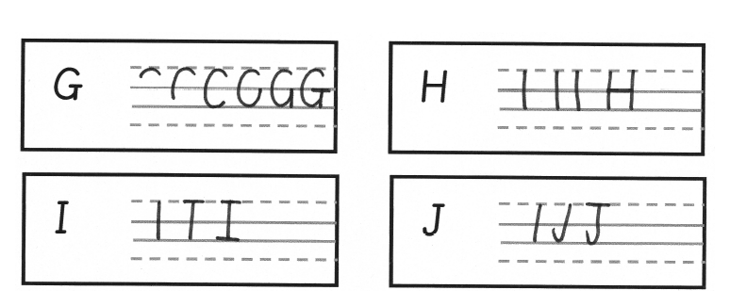

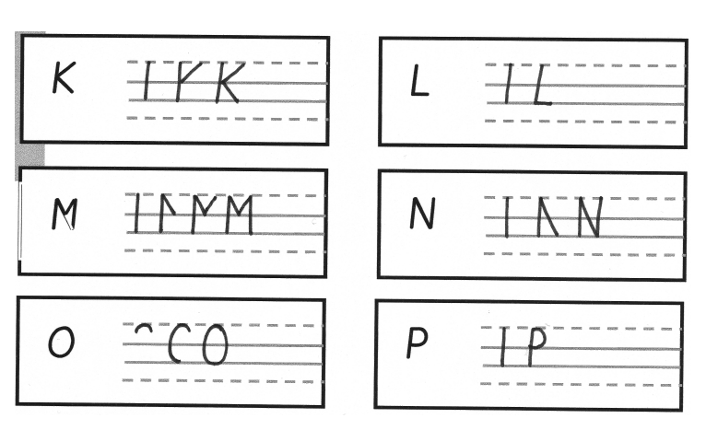

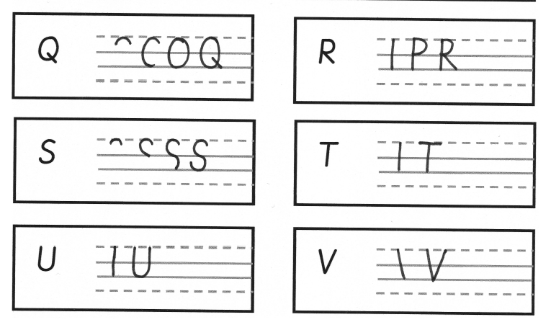

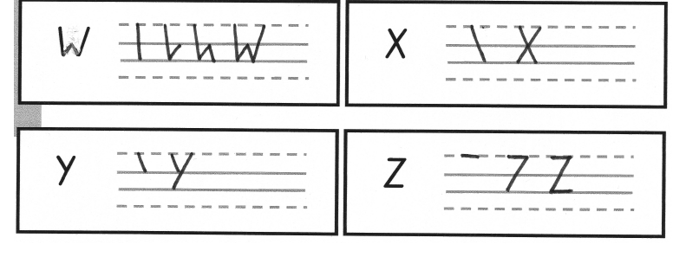

NUMBER FORMATION
All numbers are regarded as the same size as tall letters.

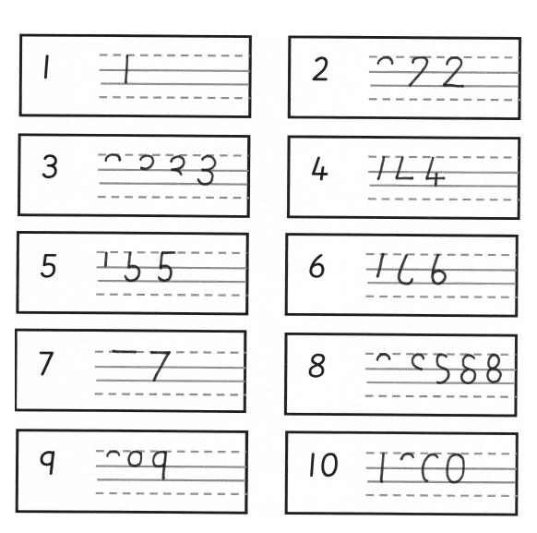

Letter Chatter
For further information to support the learning and teaching of the letter chatter please refer to ‘ISHA Achieving Excellence in Handwriting’ document, especially pages 17-19.

Lower Case Letters
a - Coat hanger hook, down, round, up, down, joining line.
b - Tall line, up, round, down, round.
c - Coat hanger hook, down, round.
d - Coat hanger hook, down, round, up, up, tall line, joining line.
e - Across, coat hanger hook, down, round.
f - Coat hanger hook, tall line, down, round. Pencil off. Across.
g - Coat hanger hook, down, round, up, tall line, round.
h - Tall line, narrow bridge, joining line.
i - Short line, joining line. Pencil off. Dot.
j - Tail line, round. Pencil off. Dot.
k - Tall line, up, shoe lace, joining line.
l - Tall line, joining line.
m - Short line, narrow bridge, narrow bridge, joining line.
n - Short line, narrow bridge, joining line.
o - Coat hanger hook, down, round, up, joining line.
p - Tail line, up, up, round, down, round.
q - Coat hanger hook, down, round, up, tail line, diagonal.
r - Short line, up, bridge, joining line.
s - Coat hanger hook, diagonal, round.
t - Tall line, round. Pencil off. Across.
u - Short line, round, up, down, joining line.
v – Diagonal, diagonal, joining line.
w - Diagonal, diagonal, diagonal, diagonal, joining line.
x - Diagonal, joining line. Pencil off. Diagonal .
y - Short line, round, up, tail line, across.
z - Across, diagonal, across.

Upper Case Letters
A – Diagonal. Pencil off. Diagonal. Pencil off. Across.
B - Tall line. Pencil off. Across, round, across, across, round, across.
C - Coat hanger hook, down, down, round.
D - Tall line. Pencil off. Round, down, down, across.
E - Tall line, across. Pencil off. Across (top broken line) Pencil off. Across (top solid line).
F – Tall line. Pencil off. Across (top broken line) Pencil off. Across (top solid line).
G –Coat hanger hook, down, down, round, up. Pencil off. Across.
H – Tall line. Pencil off. Tall line. Pencil off. Across.
I – Tall line. Pencil off. Across (top broken line). Pencil off. Across (bottom solid line)
J – Tall line, round. Pencil off. Across.
K – Tall line. Pencil off. Diagonal, diagonal.
L – Tall line, across.
M – Tall line. Pencil off. Diagonal, diagonal, tall line.
N – Tall line. Pencil off. Diagonal, up, up.
O – Coat hanger hook, down, down, round, up, up.
P – Tall line. Pencil off. Round, down, across.
Q - Coat hanger hook, down, down, round, up, up. Pencil off. Diagonal.
R – Tall line. Pencil off. Round, down, across, diagonal.
S - Coat hanger hook, diagonal, round.
T – Tall line. Pencil off, across.
U – Tall line, round, up, up.
V – Diagonal, diagonal, joining line.
W – Diagonal, Diagonal, Diagonal, Diagonal, joining line.
X –Diagonal. Pencil off. Diagonal
Y – Diagonal(top solid line). Pencil off. Diagonal (bottom solid line)
Z – Across, Diagonal(bottom solid line), across.

Numbers
0 - Coat hanger hook, down, down, round, up, up.
1 - Tall line.
2 - Round, diagonal, across.
3 - Round, down, across, across, down, round.
4 – Down, across. Pencil off. Down.
5 - Short line, round, down, round. Pencil off. Across.
6 – Down and out, round, up, round.
7 – Across, diagonal.
8 – Coat hanger hook, diagonal, round, diagonal.
9 – Coat hanger hook, down, round, up, tall line.

Programme of Lessons Key Stage 1
For further information to support the learning and teaching of the KS1 programme of lessons please refer to ‘ISHA Achieveing Excellence in Handwriting’ document pages 26-34.

Warm up exercises:
Using the lines guides to support children understanding the size of small, tall and tail letters.
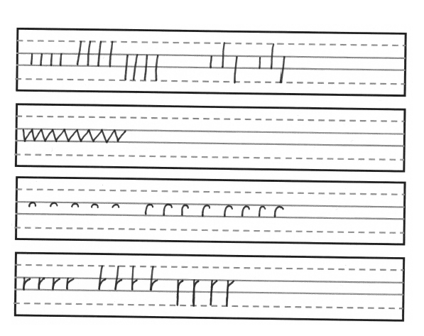

Individual letters | Examples | CT Notes
- i and l. | 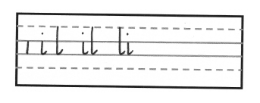
- i, l and j. | 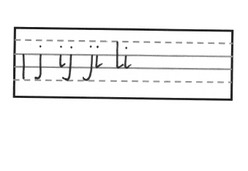
- i, l and t. | 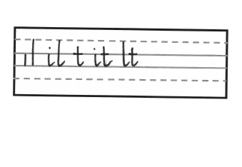
- r, n, h and m. | 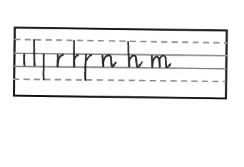
- b, p and k. | 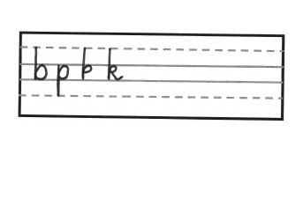
- r, n, h and m (recap). | 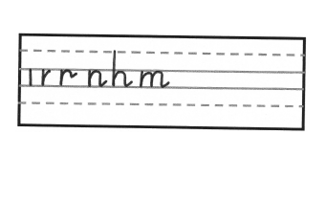
- b, p, k and r (recap). | 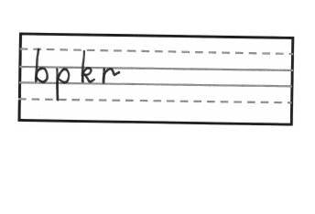
- v and w. | 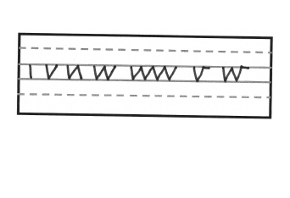
- vi, vl, wn and wr. | 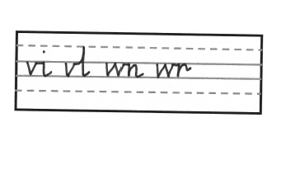
- u and y. | 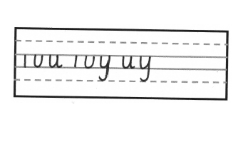
- c, o, ou and oy. | 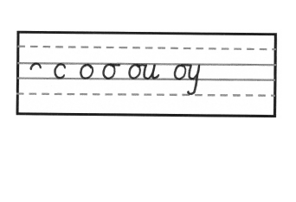
- a, d, g and q. | 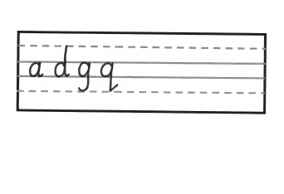
- e | 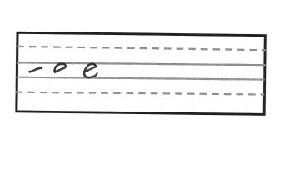
- ov, ow, on and or. | 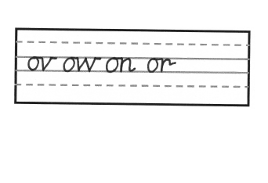
- c, ca, e and eq. | 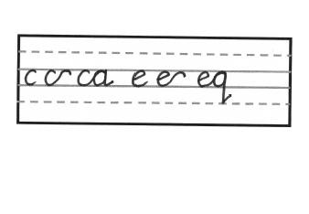
- s, i, k and ks. | 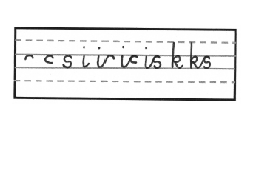
- f, fi and fr. | 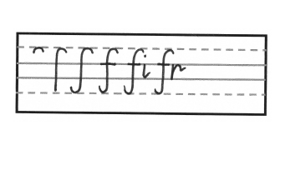
- x, e, ex, a and ax. | 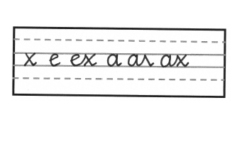
- z, i, iz, a and az. | 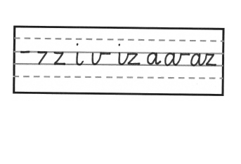
Capital letters and numbers | Examples | CT Notes
- P, B, R, D and U | 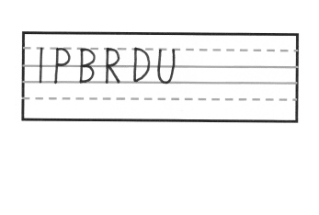
- L, E, F, M and A | 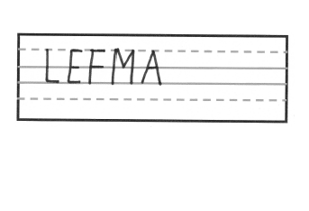
- T, U J, H, K and N | 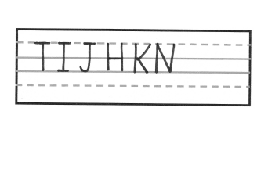
- C, G, O, Q and S | 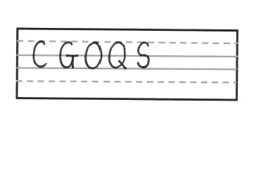
- X, V,, W, Y and Z | 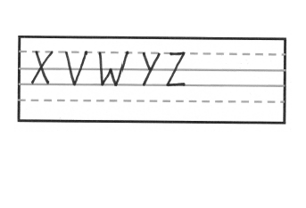
- 1 and 2 | 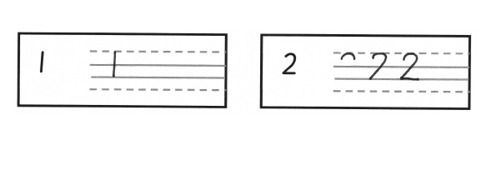
- 3 and 4 | 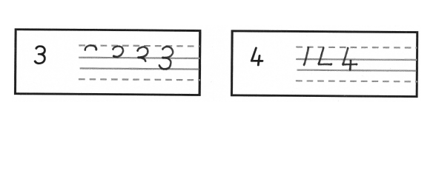
- 5 and 6 | 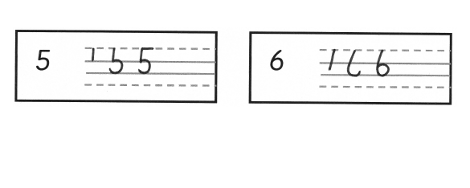
- 7 and 8 | 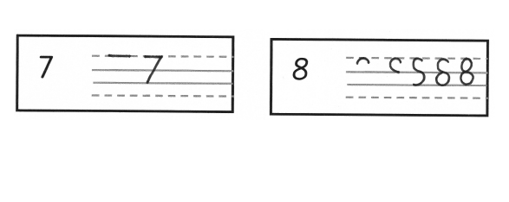
- 9 and 10 | 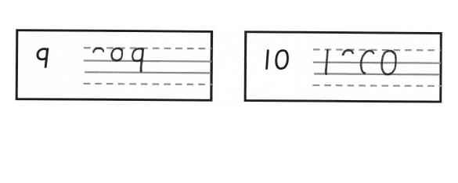
Joining letters | Examples | CT Notes
For further information to support the learning and teaching of joining pairs of letters please refer to ‘ISHA Achieving Excellence in Handwriting’ document pages 19-24.

- al, ab, ia and va. | 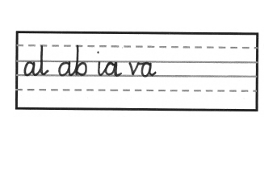
- ib, ob, lp and mp. | 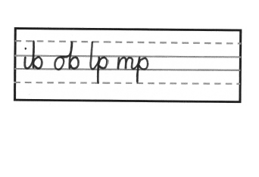
- ck, cy, nc and oc. | 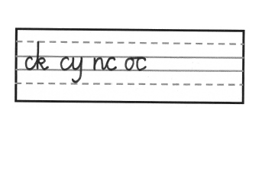
- de, dr, da and nd. | 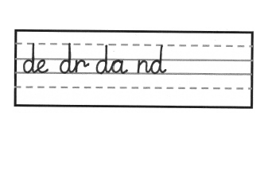
- em, ke, ej and oj. | 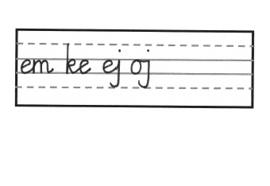
- fo, fa, uf and of | 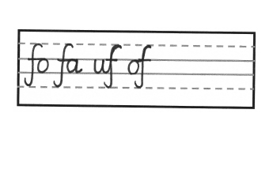
- ng, dg, iq and oq. | 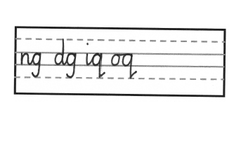
- ht, ha, wh and th. | 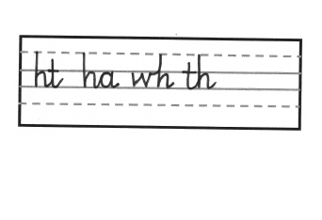
- ki, mi, cl and wl. | 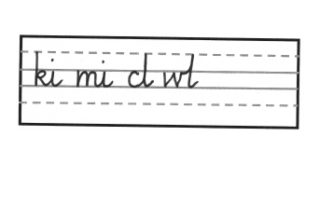
- ky, kn, ok and rk. | 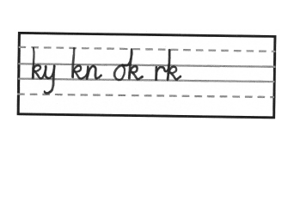
- wm, am, ny and en. | 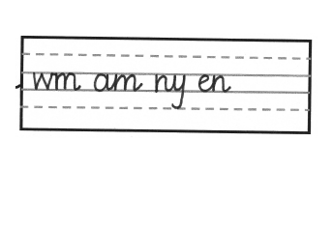
- qu, nq, us and os. | 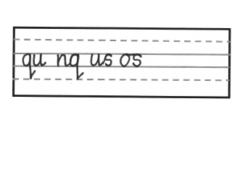
- lt, it, lit, cu and up. | 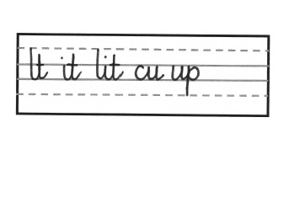
- ev, nv, wo and we. | 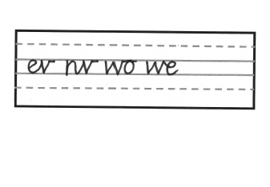
- vy, zi, ze and iz. | 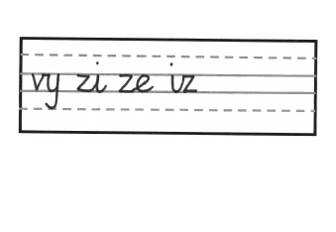

Programme of Lessons Key Stage 2
For further information to support the learning and teaching of the KS2 programme of lessons please refer to ‘ISHA Achieving Excellence in Handwriting’ document pages 36-41.

Warm up exercises:
Using the lines guides to further support children in KS2 understanding the size of small, tall and tail letters.
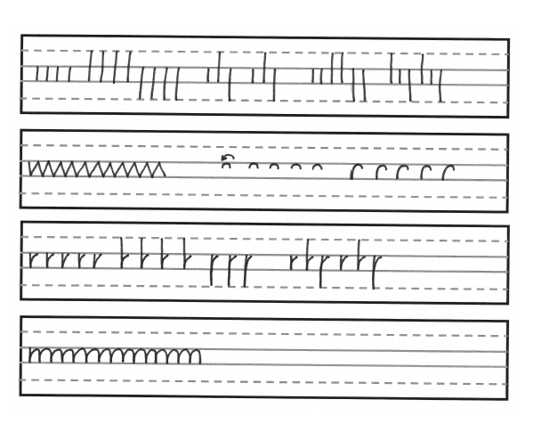

Individual letters | Examples | CT Notes
- i, l, t and j. | 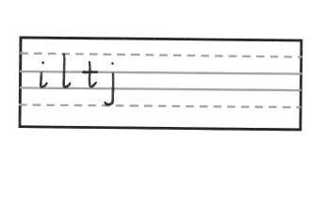
- h, n and m. | 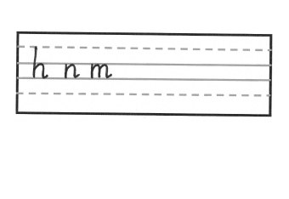
- b, p, k and r. | 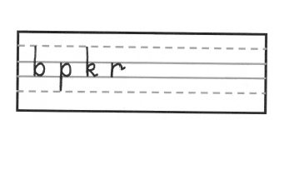
- c, o, a and d. | 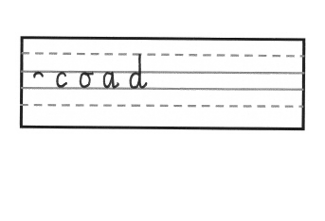
- g, q, e, l and e. | 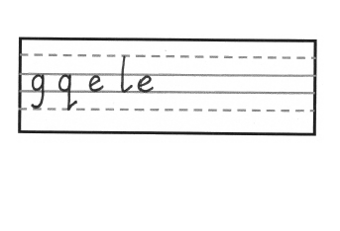
- v, w, u and y. | 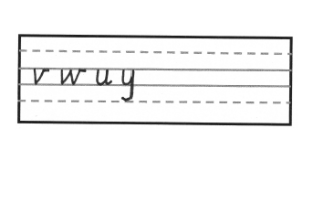
- s, f, x and z. | 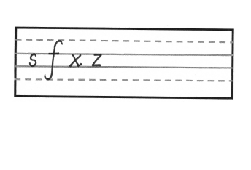
Joining letters | Examples | CT Notes
For further information to support the learning and teaching of joining pairs of letters please refer to ‘ISHA Achieving Excellence in Handwriting’ document pages 19-24.
- ac, aw, da, oa, ib and ob. | 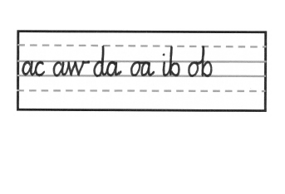
- ck, cy, ec, vc, du and dg. | 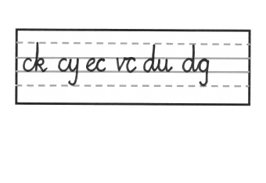
- en, ef, me, te, fr and fo. | 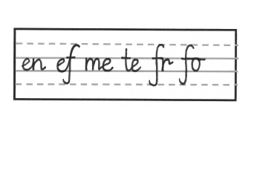
- if, af, ng, og, hs and hu. | 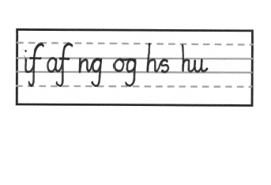
- lh, ch, ib, ip, ki and vi. | 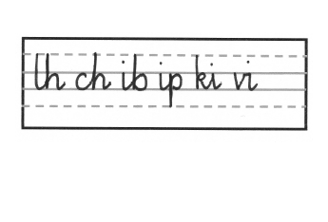
- ej, nj, ky, kl, mk and ok. | 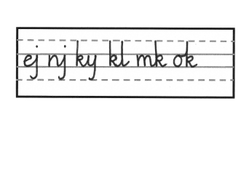
- ll, lw, cl, al, mb and mp. | 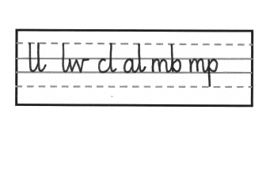
- om, im, mf, ms, ng and nt. | 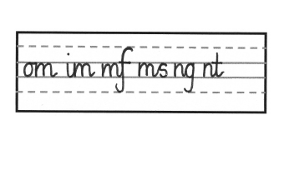
- un, wn, or, od, vo and ho. | 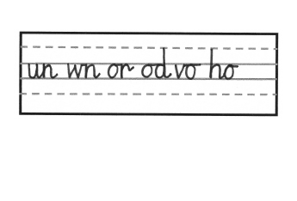
- op, rp, qu, nq and rl. | 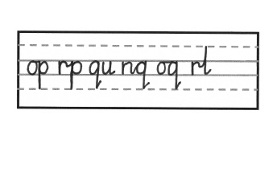
- rs, vr, tr, vs, fs and ns. | 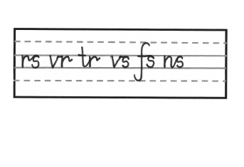
- tl, ty, ut, ot, ug and uz. | 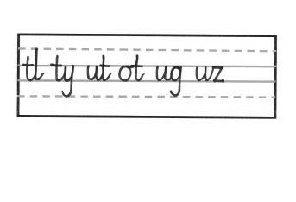
- du, fu, va, ve, ov and iv. | 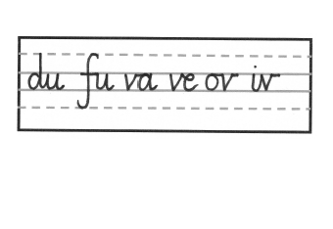
- wg, we, ow, ew, ex and ix. | 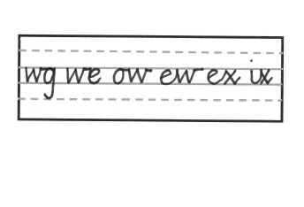
- xh, xe, vy, cy oz and ez. | 