Reception Home Learning Tasks
Week 1  To be handed in Wednesday 4th March  Next Week is World Book Week  Make a book mark 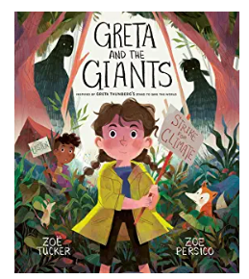  Our book next week is ‘Greta and the Gaints’. On your bookmark draw a picture of all the things in the world that you love and would want to save. | Week 2  To be handed in Wednesday 11th March  I can talk about my Favourite fairy tale story.  Please select your favourite fairy tale story. Will it be ‘Sleeping Beauty’, ‘Cinderella’, ‘Rapunzel’ or something else? Draw and/or write about why it is your favourite story. We look forward to listening to your choices and reasons.
Week 3  To be handed in Wednesday 18th March  Can you answer some simple addition and subtraction sums?  Ask your children if they can read the sum. Can your child remember which direction to jump on a number line when they complete each of the sums? | Week 4  To be handed in Wednesday 25th March  I can create a puppet of my favourite traditional tale character and use this to help me to retell the story.  Please select your favourite fairy tale story character and create your own story puppet. This can be as simple as drawing and cutting out your chosen character and sticking it on to a lollypop stick. Can you use your puppet to act out a scene from the story? Can you retell the story with expression?
Week 5  To be handed in Wednesday 1st April  I can identify coins  Please let your child play with a selection of 1p, 2p, 5p and 10p coins. Play shop or take them shopping to spend a small amount. Can they identify the coins and begin to add up different coins.  1p +1p, 2p+1p, 2p +2p, 5p+1p | Week 6  To be handed in Wednesday 22nd April  After the holidays, we will be going  ‘Into the garden’.  Keep a log of all the things that you see or might see in a garden. This could be your own garden or i a garden in a park or National Trust property or you could visit the library to see if there are some books with gardens in them
Spring 2
Please remember to check the blog page on the website for weekly news and reminders

.

