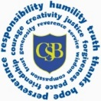
Canon Burrows EYFS half term overview

Year Group: Reception Term: Spring 2 Theme: Fairy Tales
Key question:
English  Literacy statements that are being used throughout this theme:  To use vocabulary and form of speech that are influenced by their experiences of books  Reading:  Exploring alternate endings and versions of the same story  To answer simple questions about a book or passage they have read showing good understanding  To have experience of hearing a range of different fairy tales  Reading simple instructions for making sandwiches or jam tarts  Writing:  To write their own version of the ‘Princess and the Pea’  To write key phrases from the story  To describe a main character using adjectives  To write simple sentences using their phonics knowledge  To use traditional tales language in their writing  Speaking and Listening/drama opportunities:  To retell a story orally  To hot spot a character from the story  To perform the songs | Text driver (could be more than one):  try to ensure coverage of all genres: fiction, non-fiction, poetry:  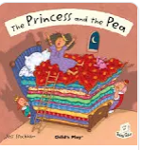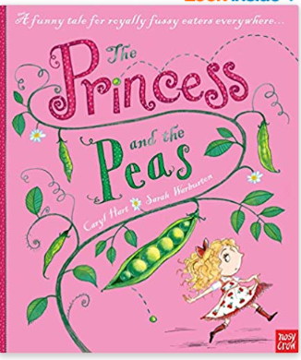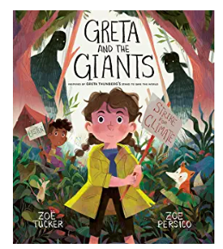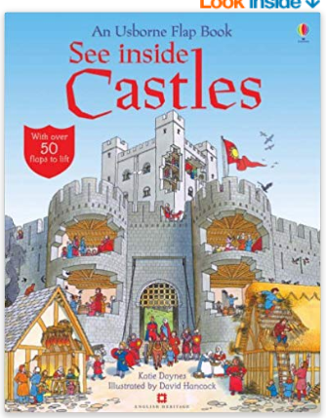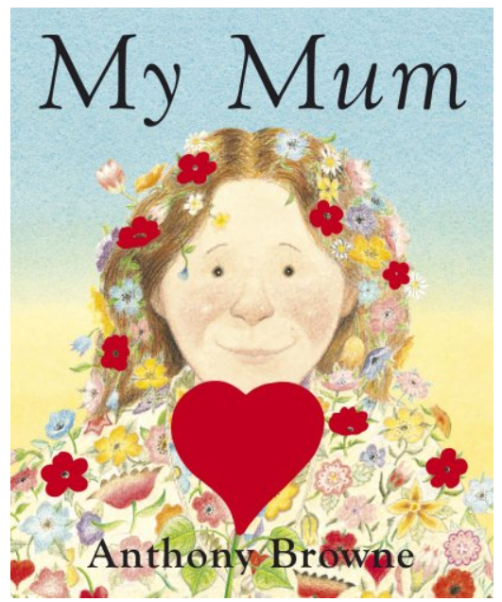 | Mathematics  Statements that are being used throughout this theme  Areas of maths to be covered:  Sharing  Halving  Doubling (recipes)  Money  Measurement (Construction – build a tall, short, wide, narrow tower/wall)  Opportunities for cross curricular links:  PSED (sharing), UW (measurement, CL throughout all activities)
Learning hooks if appropriate:
e.g trips, visitors, WOW moments

Class trip to perform The Princess and the Pea with other schools
Making Pancakes

Sky Watch Evening

World Book Week Celebrations

Physical Development  Moving and Handling and Health and self-care:  Castle building outside  Playdough Mats – comparing size and retelling stories  Explore textures by pressing playdough or clay onto different materials.  Getting changed independently or with the help of their friends into Fairy Tale outfits.  Making a bed for the princess to sleep on  Rubbings of different materials with wax crayons.  Looking at ways to transport equipment safely.  How to use tools safely. – use of knives for spreading, spoons for scooping and rolling pins.  Moving in different ways  Bed Time Routines – what do the children do? Why do they wash? Clean their teeth?  Picking Peas finger gym | Religious Education  Chatterbox focus: Easter – Palm Sunday, Good Friday, Easter Sunday  Visit for Church Service  Feelings – What it means to love and be loved? | Personal, Social and Emotional Development  Making Relationships:  PSED circle times about friendship, behaviour, attitudes towards learning, being thankful  Self Confidence & Self Awareness:  Circle time game – Pass a toy or around the circle. When a child is holding the object it is their turn to speak. Can the children say what kind of home they would like to live in? Encourage them to use their imagination – a fairy castle, a rocket ship, a house with its own football pitch!  Managing feelings and behaviour:  Thinking about feelings – linking the feelings to Religious Education learning.  Putting themselves in the place of the different characters.
Understanding the world  People and communities:  Circle time what type of home/house do you live in.  Different communitie – how is this different to the castle in the Princess and the Pea  The world:  Den building  Exploring construction materials to make beds and castles  Exploring and investigating minibeast habitats  Planting/growth  Reflect on how life was different in the past through fairy tales and pictures  Technology:  Recording a retell of the story of the.Princess and the Pea  Provide recording equipment for the children to use to record themselves telling the story.  Painting/drawing program on the computer/IWB.  Bee-Bot visiting different places in the story | Expressive Arts and Design  Exploring and using media and materials and Being imaginative:  Range of different materials to construct with/junk modelling.  Character pictures for character drawings/paintings.  Provide images from the story to encourage story-themed painting.  Design their own blanket for the princesses bed  Acting out fairy tale stories within role play  Learning and performing a variety of songs linked to the Princess and the Pea and other fairy tales.  Children to design and make their own shield with a family crest on.  Design and make their own castles and puppets to go within them.  Design a new sparkly dress for Princess Eliza or the Godmother or an outfit for the wizard | Communication and Language  Listening and attention, Understanding and Speaking opportunities:  Story /singing daily  Circle time/news/share pictures  Enhanced free choice literacy-based activities  Writing for a specific purpose – lists for a royal banquet, to make castles, invitations for Princess Eliza’s birthday, royal scrolls with messages on. Making of own spells.  Comparing different versions of the story. Story sequencing  Hot-seating.  Can they retell their own fairy tale or make up their own fairy tale?

